**1.Creating an EC2 instance:**

First we need to Login to aws account->aws management console->services->select EC2 under Compute

Click on launch Instance->choose AMI ->select other resources or click launch and review to launch with default settings, It will ask for key pair select accordingly-> click launch Instance

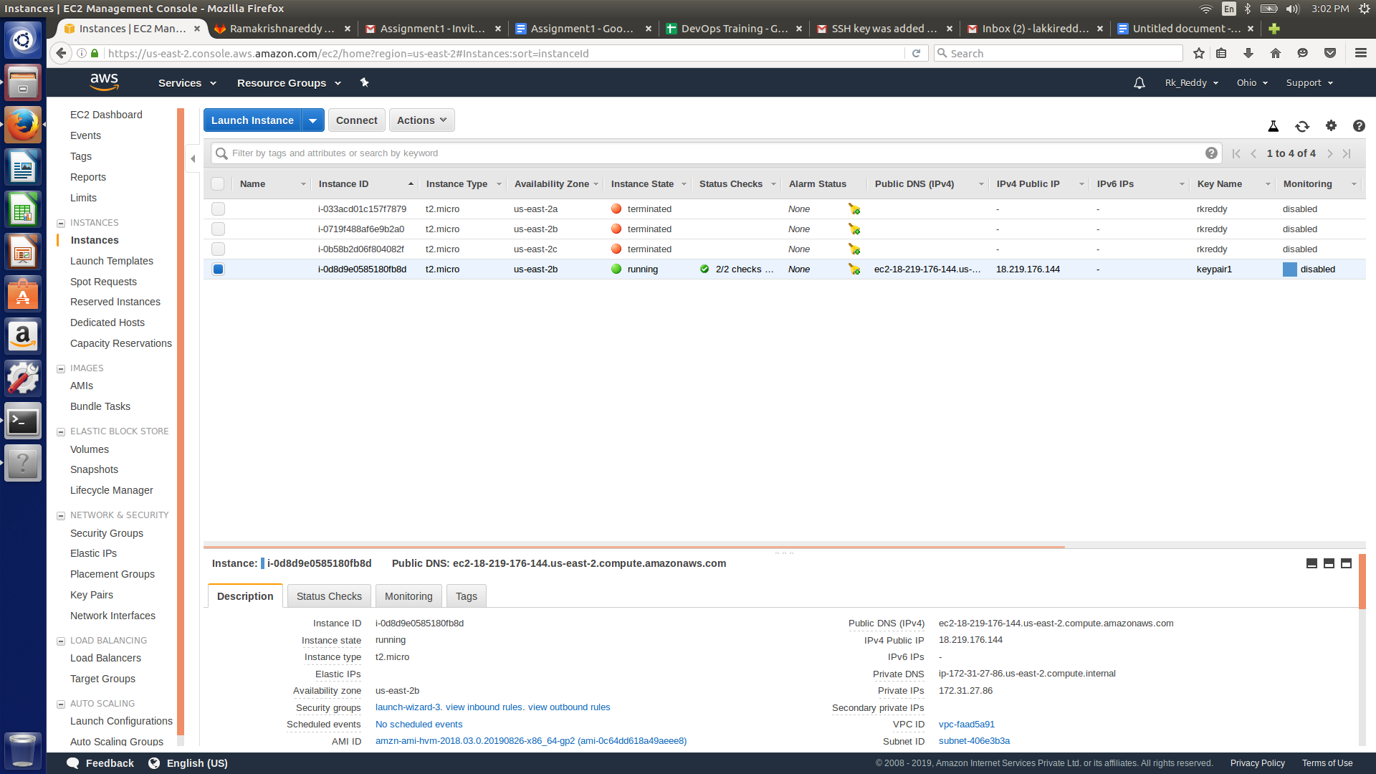

If you want To login from the CLI

Change to root user

Go to the directory where the key is downloaded

Change the permissions for the key file: chmod 400 keypair.pem

Here I named my keypair file as keypair.pem

ssh -i keypair.pem ec2-user@public_ip

for,Installing git inside your virtual server you need to type below command.

Install Git : yum install git

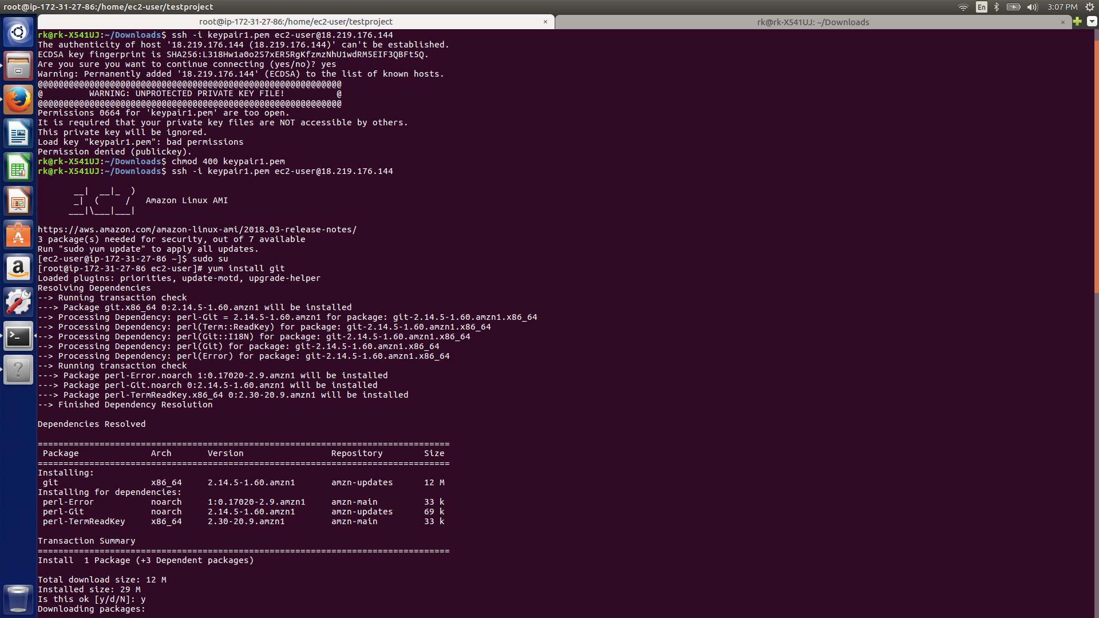

**2.Adding user:**

You need to add your gitlab credentials in the git CLI for further process.

git config --global user.name “Rk_Reddy”

git config --global user.email “rkreddii01@gmail.com”

Check user:

git config --global --list

Delete user:git config --global --unset-all

Or use:

git config -e

Remove the users which you want to delete from the file

Generate an ssh key in EC2 using ssh-keygen and add it into your gitlab account.

**3.create a repository**

Now you can clone your repository to local

git clone <link>

Make changes to the repository,add new files, commit changes and push

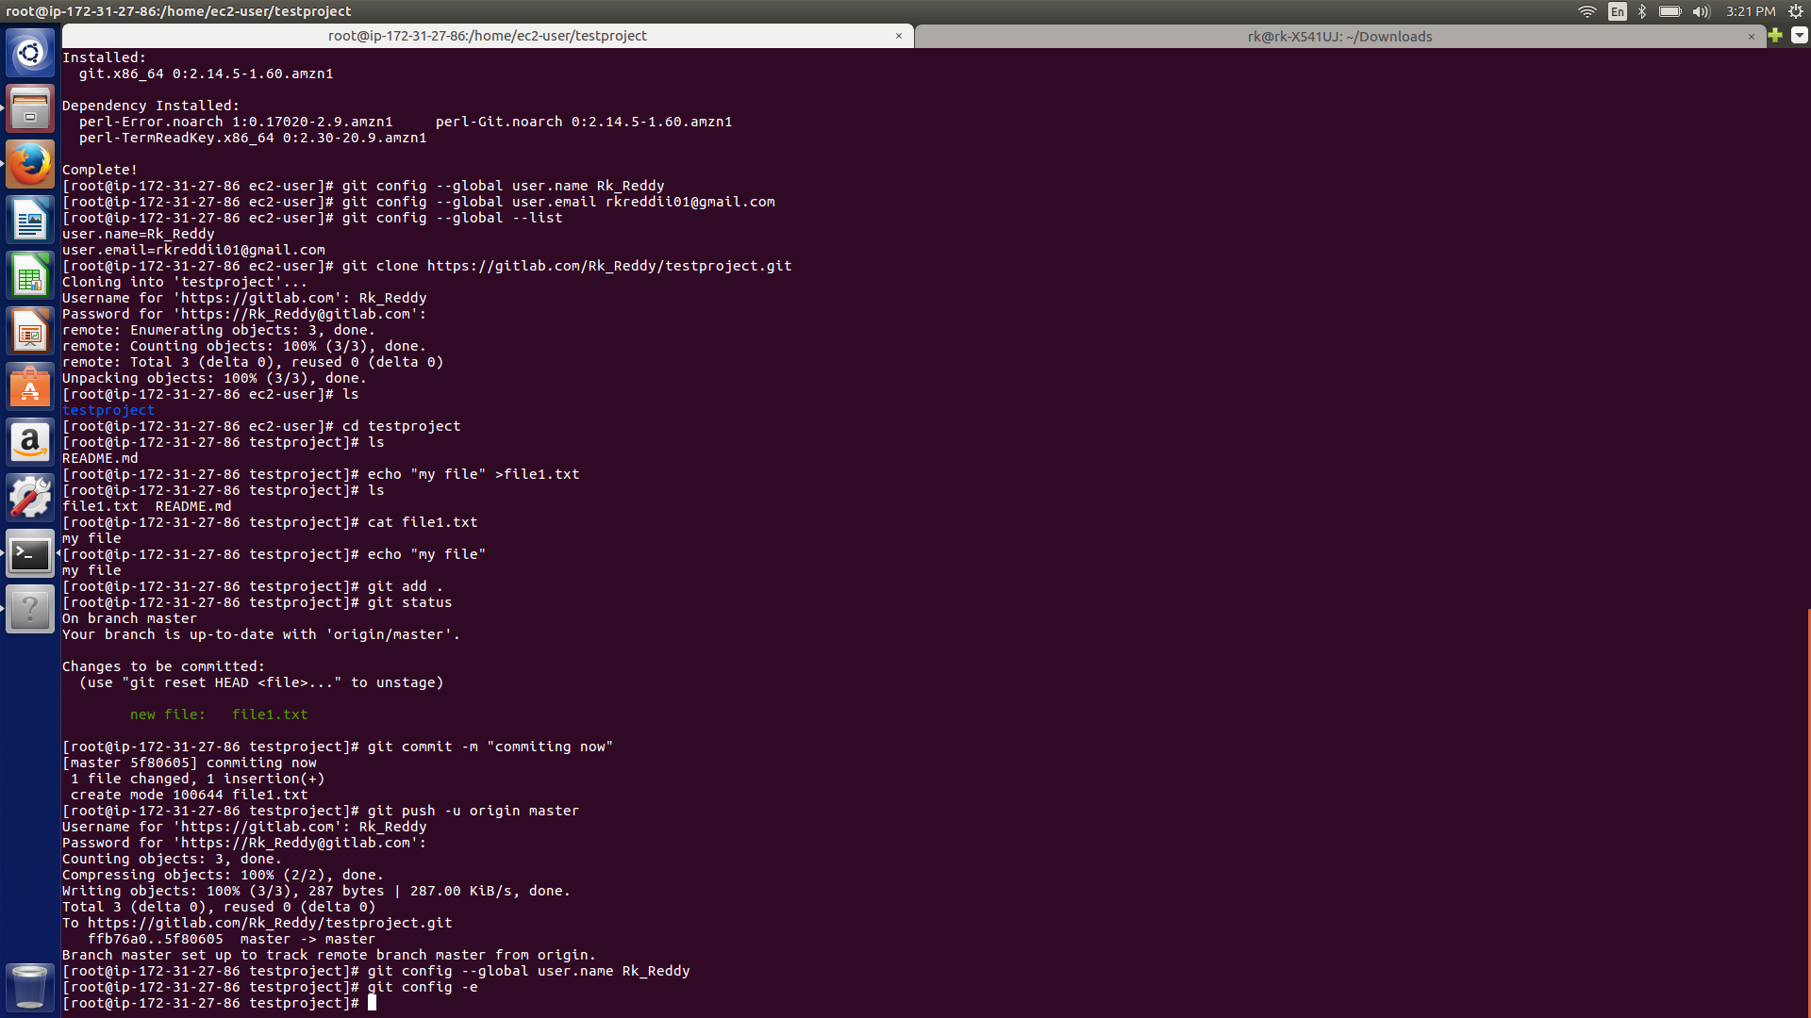

4.

**Cloning Specific branch from Repository and Pushing that into New Repository**

For that,

You need to type these commands in git CLI

Git clone <url> -b <Branch Name>

And Pull all those files from the branch and push those files into new repository

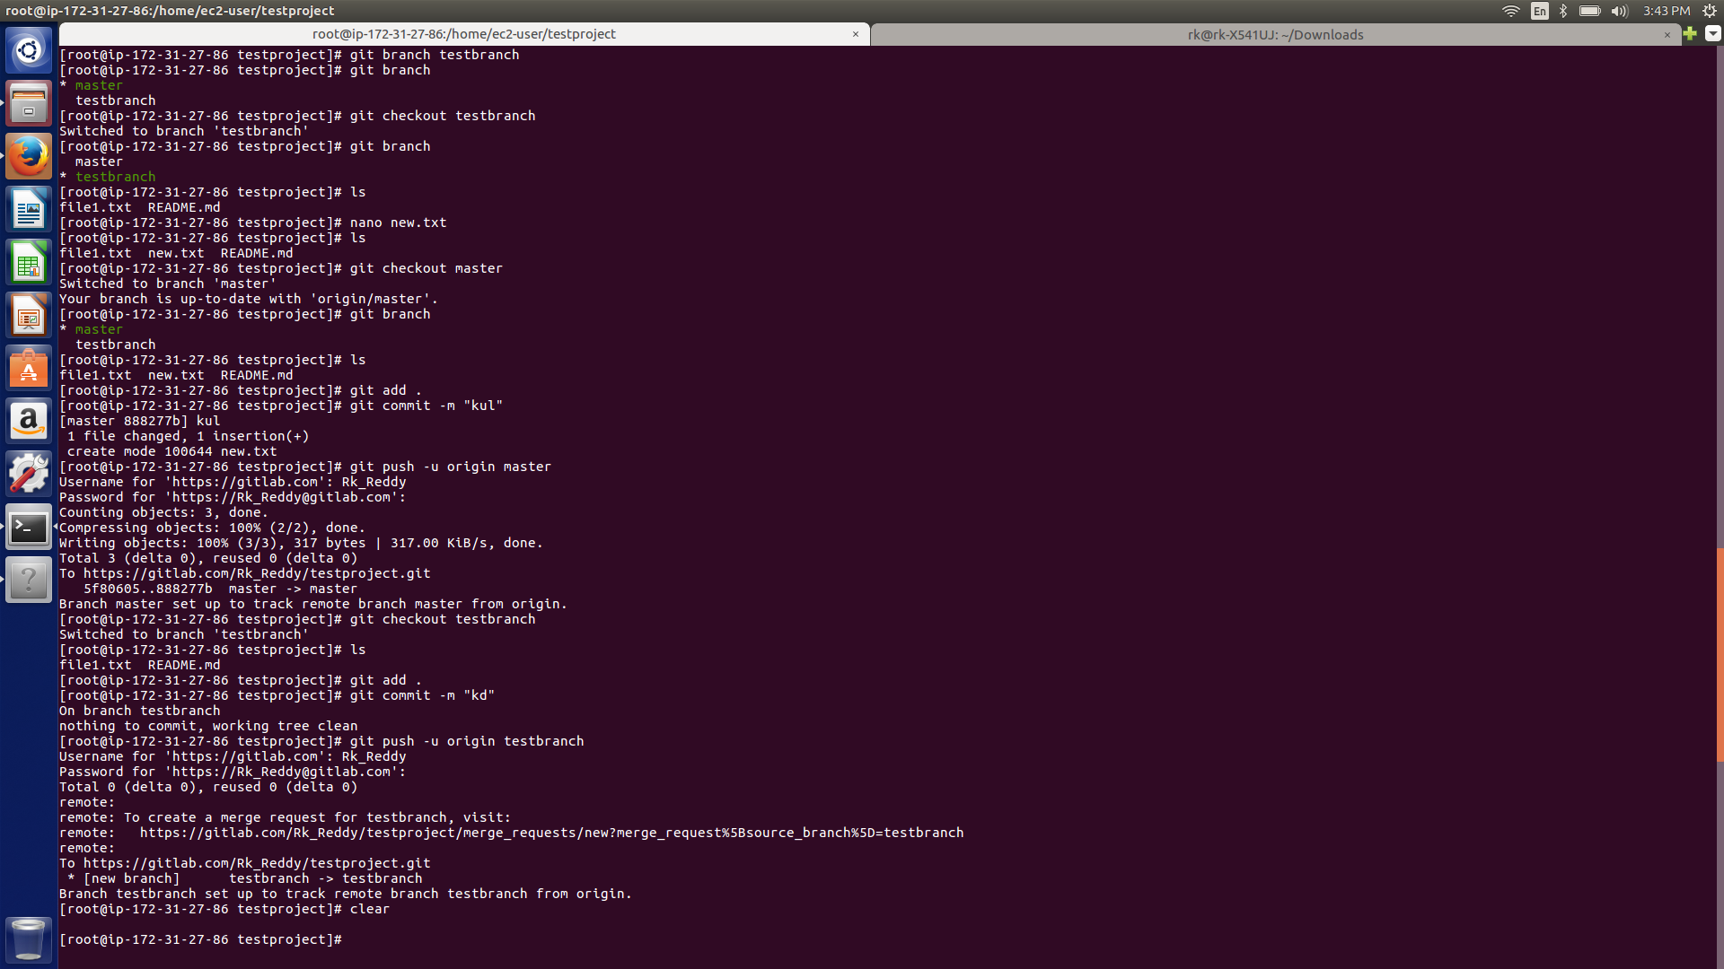

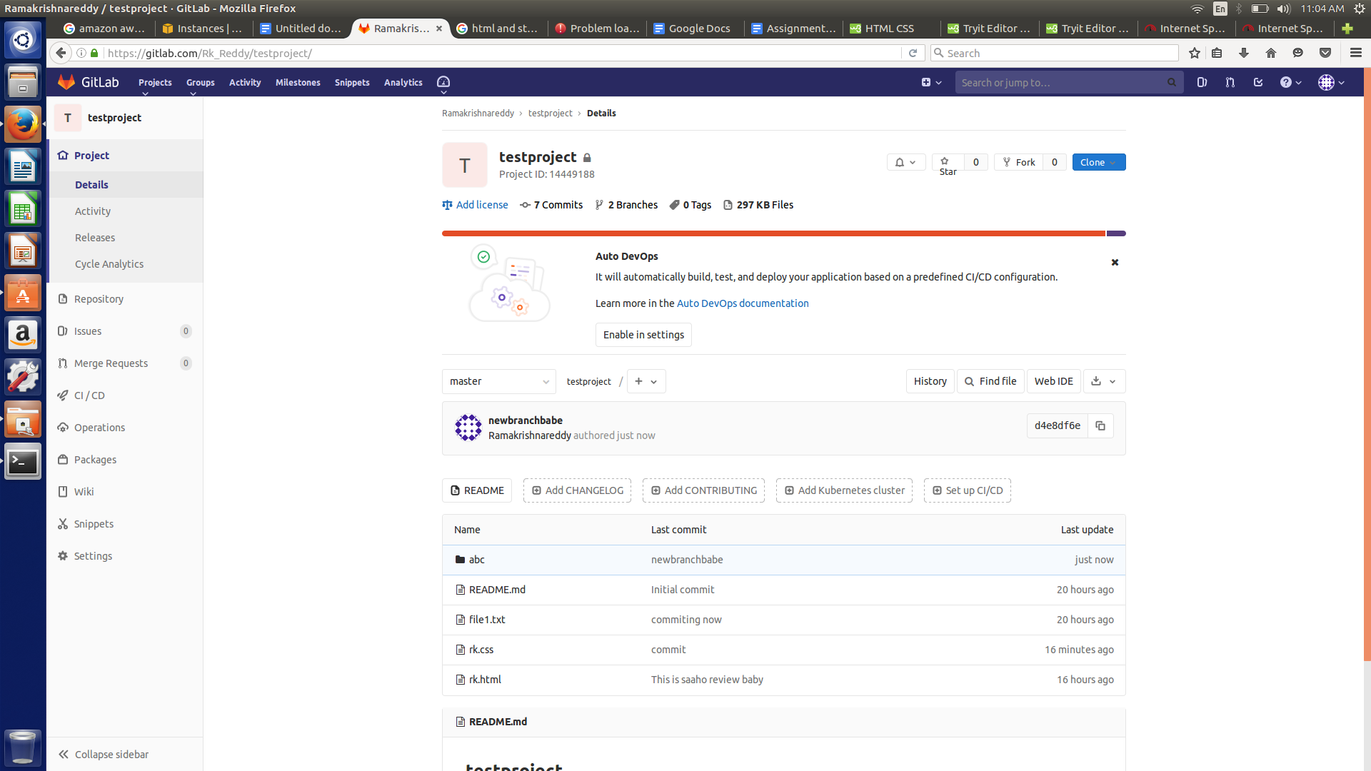

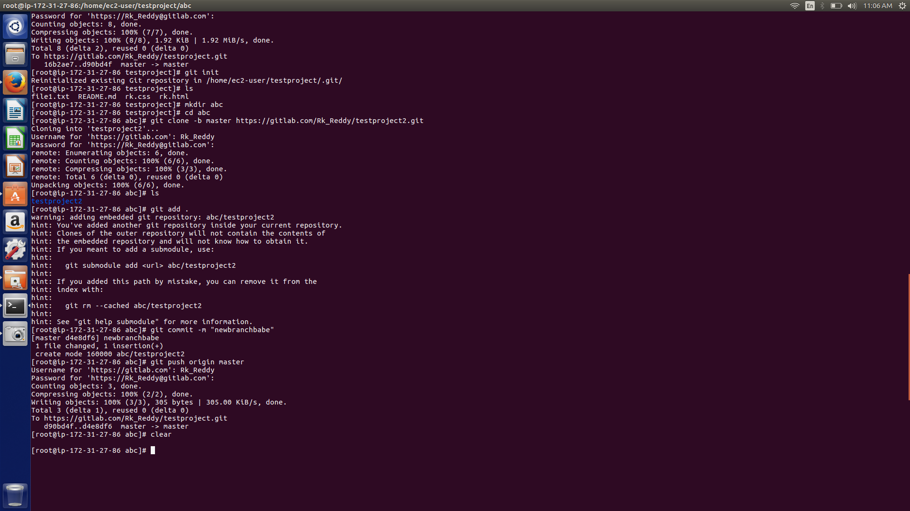

5.

**Rebasing and merging are both designed to integrate changes from one branch into another branch but in different ways.**

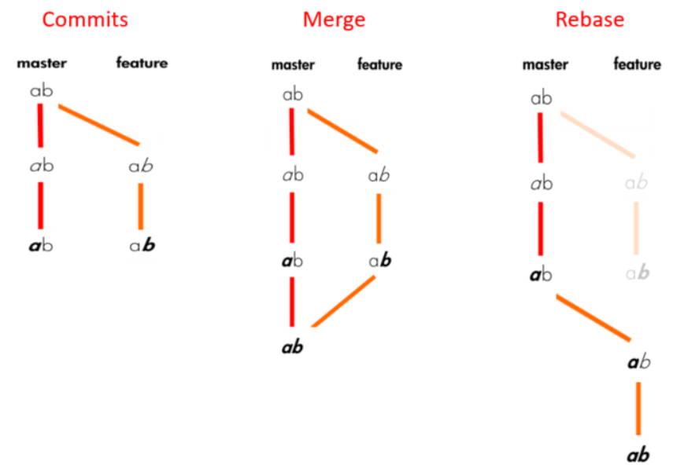

Merging takes the contents of the feature branch and integrates it with the master branch. As a result, only the master branch is changed. The feature branch history remains same.

When you do rebase a feature branch onto master, you move the base of the feature branch to master branch’s ending point.

**6.personal access token for cloning**

Creating a personal access token for the command line:-

You can create a personal access token and use it in place of a password when performing Git operations over HTTPS with Git on the command line or the API.

A personal access token is required to authenticate to GitHub in the following situations:

1.When you're using two-factor authentication

2.To access protected content in an organization that uses SAML single sign-on (SSO). Tokens used with organizations that use SAML SSO must be authorized.

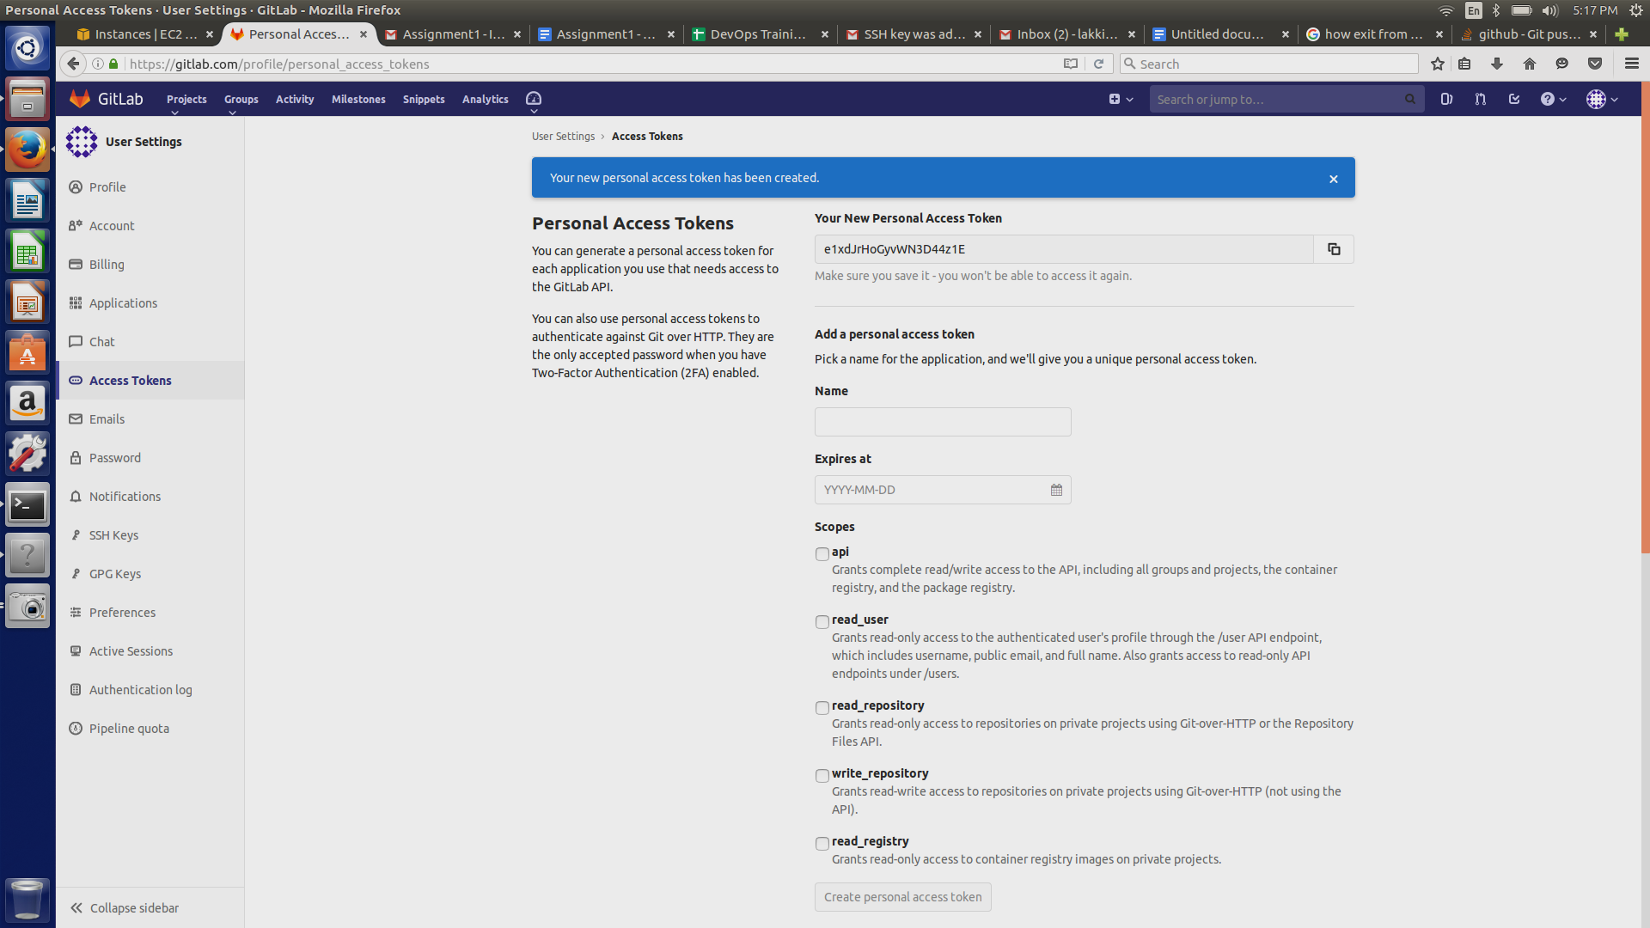

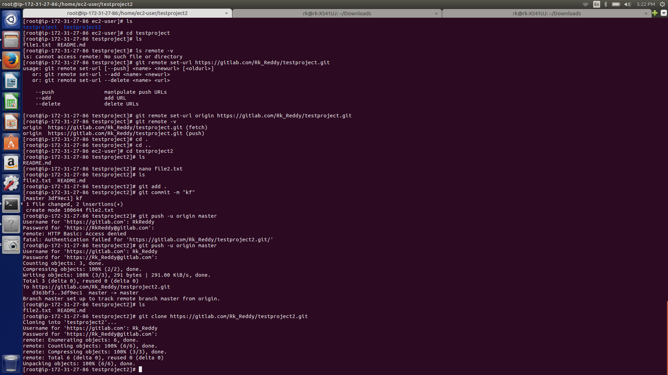

7. **On local, Create git and push to origin**

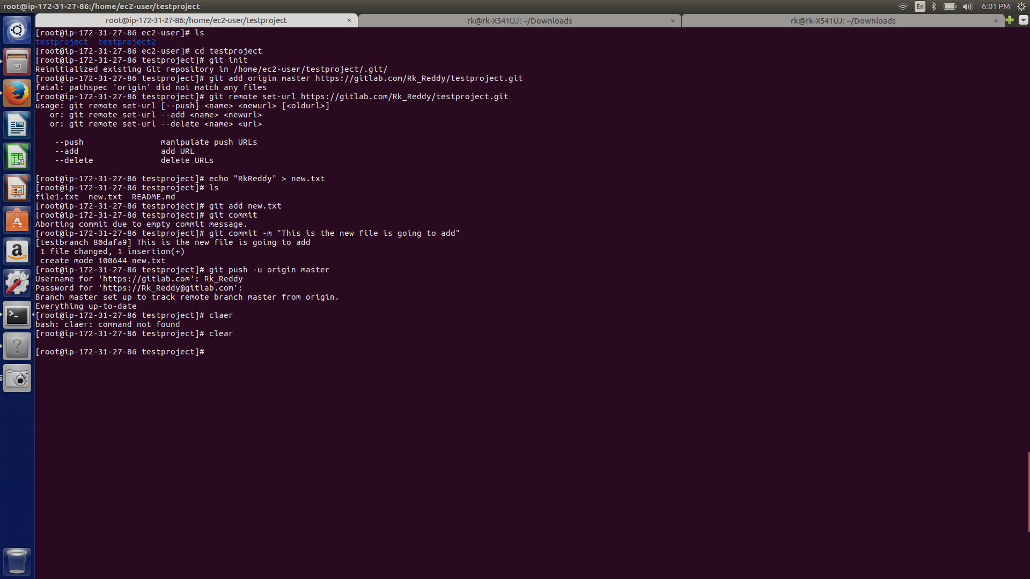

**8.Add new file to origin remote to specific branch**

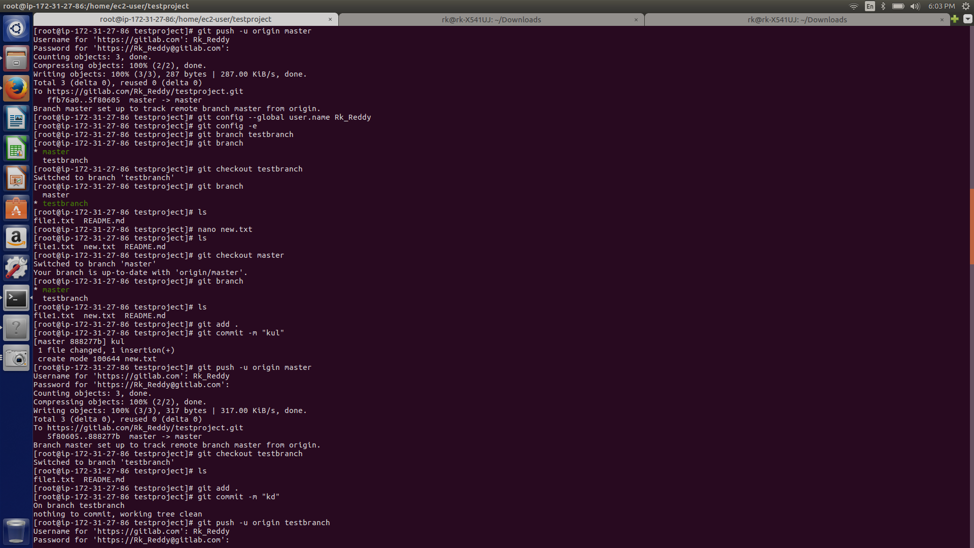

9. **HTML and Stylesheet : merge two branches**

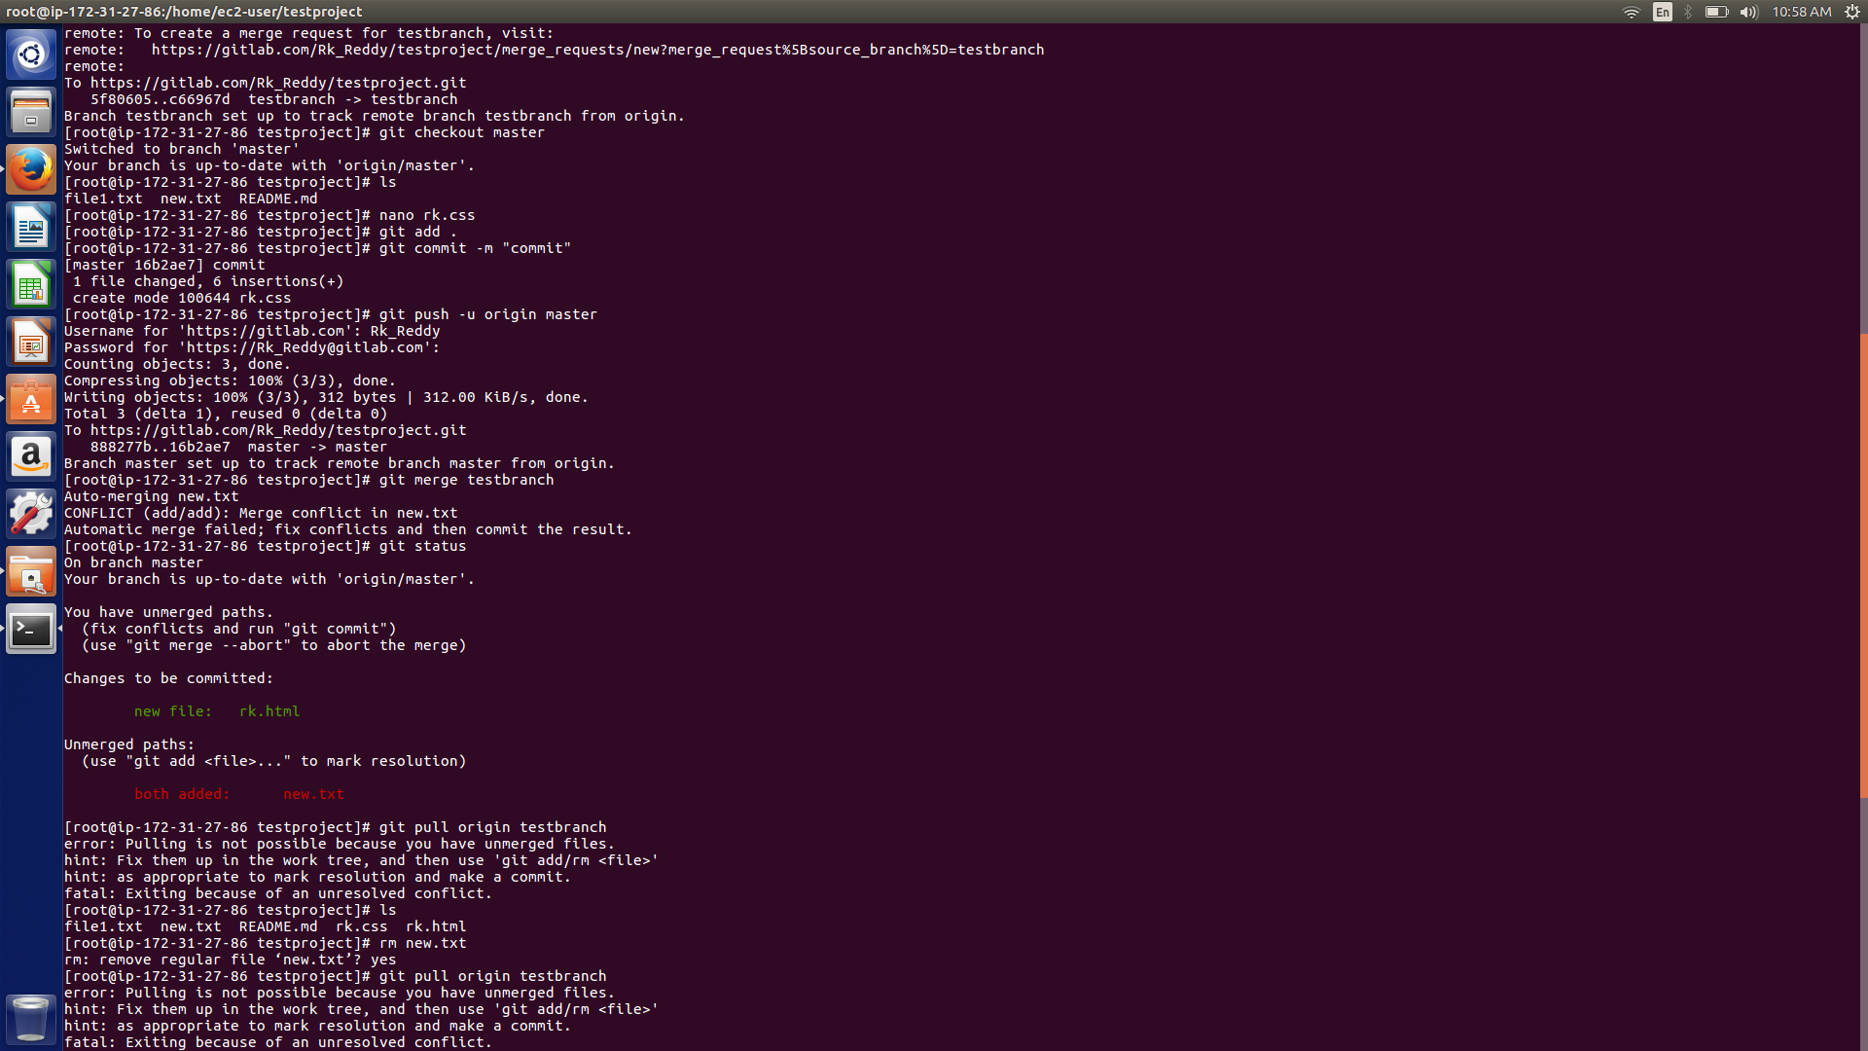

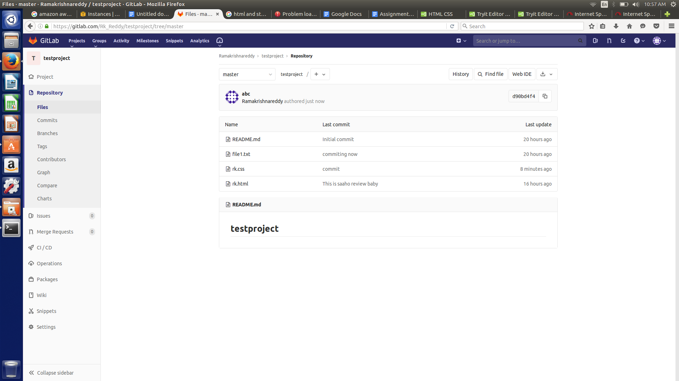

**10. Merge the code to master branch and push to remote.**

